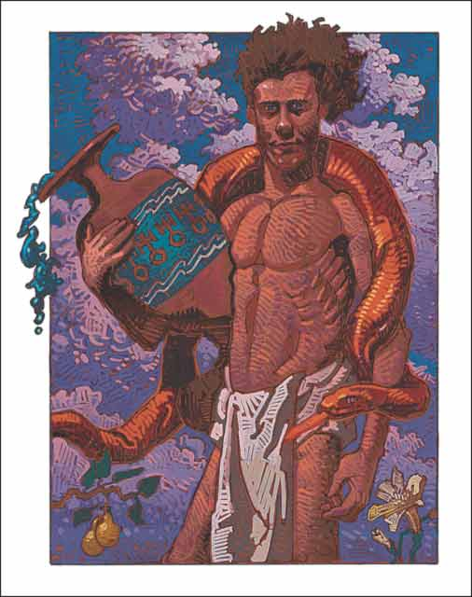

Ralph Edward Bilnoski
Snake Aquarius
February 16, 1952

In Marylin Ferguson's "Aquarian Conspiracy," she talks about how she named her book. She was noticing that there seemed to be a "movement" afoot over the entire planet (mid-to-late 80's). It was as though people from all walks of life were suddenly waking up and wanting something more. It was a silent awakening. Nobody rang a bell or sent a memo, yet they were showing up by the thousands. She believed there to be new life in this awakening
-- this gathering, so to speak.

Two thoughts stirred in her. One was that this new life was like a sip of water on the lips of a yearning civilization. This put her in mind of Aquarius -- the water bearer. The other thought was that this awakening-gathering was like a conspiracy. At first, she didn't like that word because it sounded a bit sinister. But then she realized that the actual meaning of the word "conspire" is to breathe together -- to breathe as one.

That's when she decided to name her work "Aquarian Conspiracy." Water bearers breathing together -- "life carriers" breathing as one.

The 3rd stanza of "On The Turning Away" says:

On the wings of the night
As the daytime is stirring
Where the speechless unite
In a silent accord.
Using words you will find are strange
Mesmerized as they light the flame
Feel the new wind of change
On the wings of the night

Perhaps this is how Pink Floyd described the same phenomena.

This is a portion of what I hear when I listen to my breath...

Warm regards,

John Dicus

In this stunning portrait, John Abel uses the full complement of artistic techniques — composition, color, and visual imaging — to create an icon. Decidedly this Snake-Aquarius seems sprung from Olympus.
A masculine sign, the Aquarian takes a stance that is both powerful and decisive. He looks at us straight on and is confidently steady in his task. The water bearer is the Western zodiac’s giver of wisdom. In Abel’s depiction, knowledge pours forth from a Greek amphora decorated in the brilliant blue Aquarius favors. Water spills from it like a river of sapphires, shimmering jewels of truth. Aquarius always gives us information; information that is sometimes advanced and even miraculous. There is nothing ordinary or mundane coming from the water bearer, but there is always something precious and extraordinary in his gift.
Around the young god curls a Snake. This is one of the Eastern zodiac’s most powerful signs. Fire is its element and Abel paints his serpent in flame red with embers of gold and orange burning in its scales. It is a heat that indicates the Snake has special magic and power. The Snake is wise; its world is of contemplation and tranquility, of slow and steady progress, and of sudden, preternatural insights. The serpent seems to gaze beyond ordinary limits and boundaries and into the very heart of situations and people. When the Snake is combined with the truth-giving Aquarius, the result is a personality of subtle power and intellect.
Abel’s brush strokes recur in a flawless manner. His details are both arresting and pertinent. At the bottom of the painting two Aquarian symbols offer perfect balance. A golden pear tree fruits at the left, an orchid blooms at the right. These signify beauty and sustenance, the true gifts of life. When the Snake is combined with the truth-giving Aquarius, the result is a personality of subtle power and intellect. Snake-Aquarius, once encountered is very, very hard to forget and literally impossible to dismiss.

