Rotary Assambley of West Siberia Rotary Clubs “On the Eve of 2001”

I was told that I would provide a format of meeting just on the Conference and it was not mentioned in the program my husband as the Assistant of the District Governor 5010 in West Siberia was discussed with the organizers of the Assembly. In a program it was the Round Table “How do you live, Rotary” and I thought that my proposal with OS was not accepted. Later my husband told me that that is the same as the situation in which I put participants of the OS: here is the plan of the Conference (empty wall). OK.

The room was also far from that we need for the Conference, as it was a nice seating room with the fire place but no walls and space for flip charts. I did not bring flip charts with principals and one law, so I need to make them just at a time given.

I asked for permission to use the Rotarian Hammer as the pointer and it worked well as the “microphone” at the closing session. The only “spare” wall space was near the stuffed dear head (the poor dear, killed by the hunters in a hunting season), so that was the market place for our topics which participants wanted to discuss.

I think it could be the most unusial market place and microphone for OS:

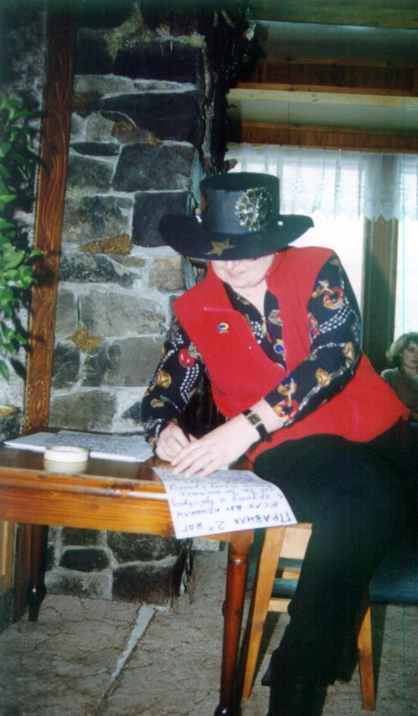

Thank you for the idea of Harrison Owen with the Hat of a Trainer (I saw the video film with his presentation of the OS) for which I used the Rotary Hat I prepared for the evening party of the Assembly – so you can see the Rotarian Symbols as well.

I think we had good results and an unusual format of discussion for the participants, as they mention in the closing session. And it was really democratic and the volunteerly spirit which was absent for example in the Housing Service Meeting. All the participants were working and not just listening and looking how others were doing things, so it was great experience, though the very strong active part of the Rotary in West Siberia tried to systematize the topics and to lead it somehow and I tried not to interfere though I saw this, but that would be the same thing which they were doing. So somehow they made two groups and worked and some were going to discuss the rest of the topics which were not discussed as it was a very short time period. So it looks more as the presentation of the method but we still managed to do a great progress, as I see it, in two hours.
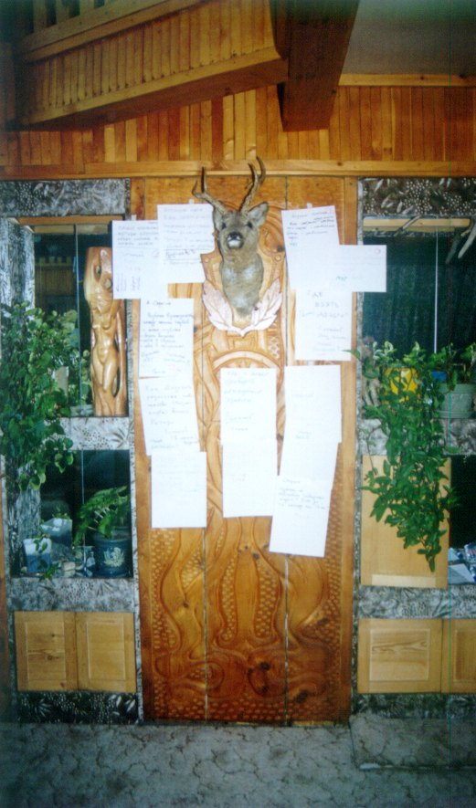

There were 14 topics proposed by the participants and they were from the very top problems of “Creating the Siberian Rotarian District in nearest soon” to the very essential one – “Why people enter the Rotary Clubs”, “Where to look for money for Rotarian programs for orphans and eldery people, for students and professional exchange”, “How to make the right image of the Rotary Clubs in Russia, that that is not massons lodge” and so on and even “Who knows, where is a tea?” – which was the simplest and quickest question to be answered and it was mentioned, that we did solve one problem of the participant.

Groups worked very intensive!
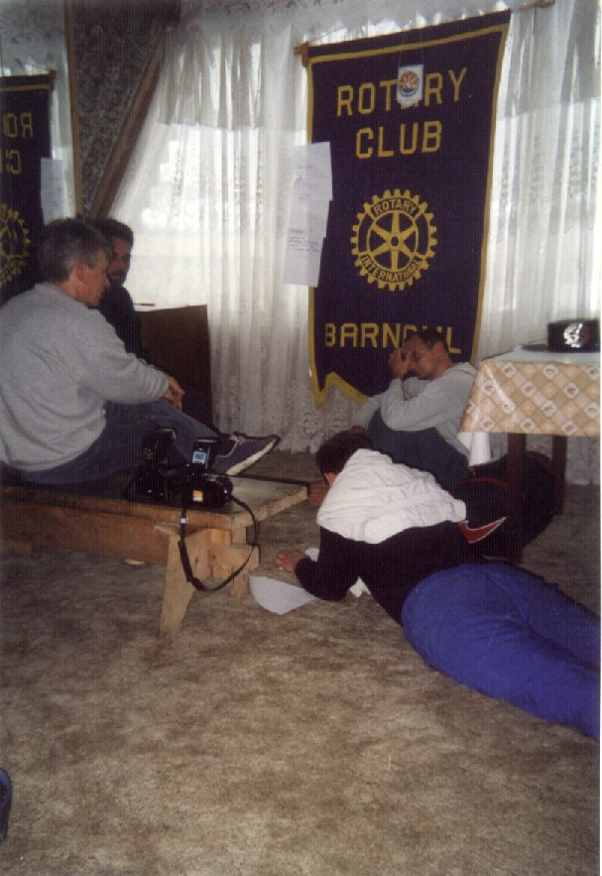

And made deep reports.

And we (my husband and me) played a role of magicians at the end of the Assembly: to srtruggle with Magic Rotarian Wheels with the Russian roadlessness and Disorder…
